**KINGOM OF SAUDI ARABIA …………………………………. Education directorate**

**MINISTRY OF EDUCATION ……………………………. Elementary school**



|  |  |  |  |  |
| --- | --- | --- | --- | --- |
| **14/2 _ 18/2 1st week From** | | | | **Unit 1**  **It’s Nice to Meet You!** |
| **SB_P4** | **SB_P3** | **SB_P2** | **Finding Out Time , Grammar** |
| **2nd week From 21/2 _ 25/2** | | | |
| **SB_P34** | **SB_P6,7** | **SB_P5** | **Grammar, Rhythms & Reading** |
| **3rd week From 28/2 _ 2/3** | | | |
| **SB_35** | **SB_9** | **SB_P8** | **Phonics, Phonics Practice** |
| **4th week From 5/3 _ 9/3** | | | | **Unit 2**  **Sea Animals** |
| **SB_P13,37** | **SB_P36,12** | **SB_10,11** | **Finding Out Time, Grammar** |
| **From 12/3 _ 16/3 5th week** | | | |
| **SB_P17** | **SB_P16** | **SB_P14,15** | **Rhythms & Reading , Phonics** |
| **From 19/3 _ 23/3 6th week** | | | | **Unit 3**  **Sports and Activities** |
| **SB_P19** | **SB_P18** | **إجازة اليوم الوطني** | **Finding Out Time** |
| **From 26/3 _ 30/3 7th week** | | | |
| **SB_P23,38** | **SB_P22** | **SB_P20,21** | **Grammar**, **Rhythms & Reading** |
| **From 3/4 _ 7/4 8th week** | | | |
| **SB_P39** | **SB_P25** | **SB_P24** | **Phonics, Phonics Practice** |
| **From 10/4 _ 14/4 9th week** | | | | **Unit 4**  **Chores** |
| **SB_P40** | **SB_P28.29** | **SB_26,27** | **Finding Out Time , Grammar** |
| **From 17/4 _ 21/4 10th week** | | | |
| **SB_P32,33** | **SB_P31** | **SB_P30** | **Rhythms & Reading , Phonics** |
| **From 24/4 _ 28/4 11th week** | | | |
| **Remedial Plans** | **SB_P41** | | **Phonics Practice , Revision** |
| **From 1/5 _ 5/5** | | | | **12th**  **week** |
| **End of the continuous evaluation**  **Remedial Plans** | | | |

**SYLLABUS DISTRIBUTION FOR 3rd ELEMENTARY GRADE**

**(WE CAN 3) (FIRST TERM) 1446 H**

إجازة مطولة إجازة اليوم الوطني

**Teacher…………….… Headmaster………………. Supervisor ……………….**

SB كتاب الطالب Pرقم الصفحة بكتاب الطالب

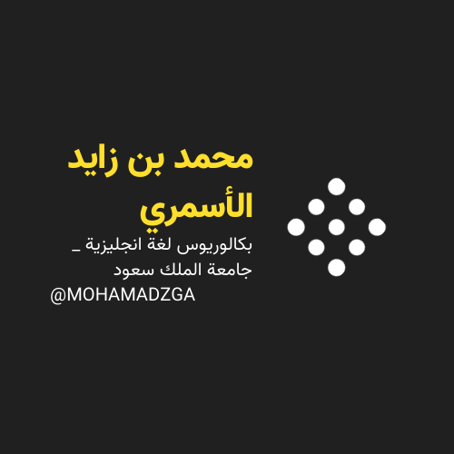



**قناتي**



**MOHAMADZGA M_zaid0**

**لا تنسوني من صالح دعائكم**